SHEET -6 – SPECIAL FILE PERMISSIONS

1. Use which cmd to check the where are its executable files
   1. Which pwd
   2. Which passwd
   3. Which su
   4. Which mount
   5. Which gpasswd

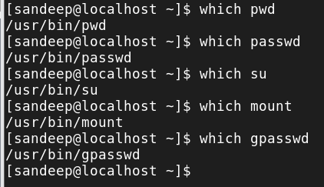

1. List all the files having special permission 4 – setuid
   1. Find /usr/bin -type f -perm -4000

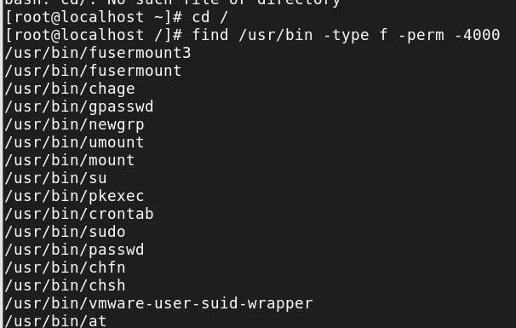

* 1. Use **find** to get all files with spl perm 2- setgid from /usr/bin

1. List all the directories having special permission 2 – setgid from / directory (use find / -type d -perm -2000)

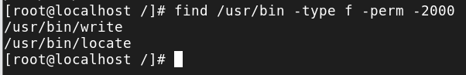

1. Run ls -l /usr/bin/gpasswd and observe the permission (-rws-r-x-r-x)

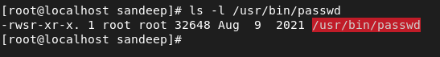

* 1. Run the same for passwd and sudo and chmod and observe.

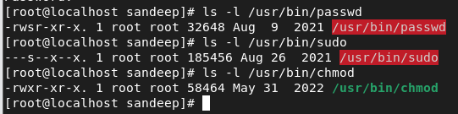

* 1. Run ls -l /usr/bin/locate and observe the permission (-rwx--s--x)



* 1. Run ls -l /usr/bin/write and observe the permission (-rwxr-sr-x)



* 1. Run ls -ld /tmp and observe the permission (drwxrwxrwt)



1. Set up a directory, owned by the group sports. (setGID -4)
   1. Members of the sports group should be able to create files in this directory.
   2. All files created in this directory should be group-owned by the sports group.
2. Use (chmod g+s dir/filename) and also using octal values (chmod 2775 dir/filename)

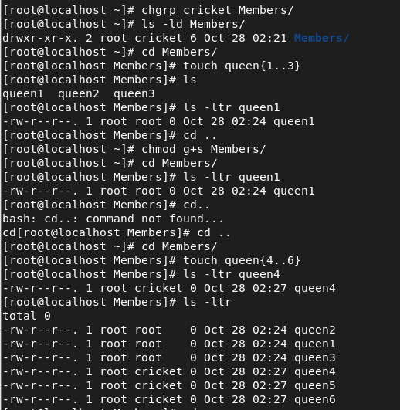

* 1. Users should be able to delete only their own user-owned files.

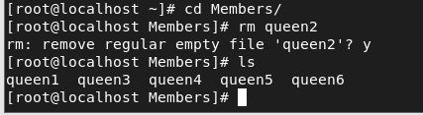

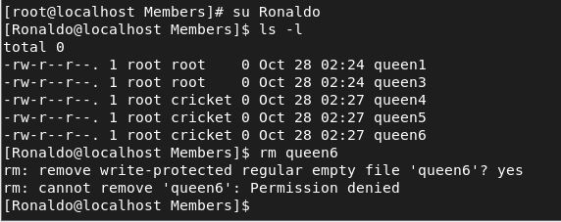

* 1. Check if this works.
  2. Try removing the permissions also and checking(chmod g-s dir.filename)

1. Create files and try setting and removing setuid permissions (setUID -2) and chk using ls -l filename

a. Chmod u+s filename

* 1. Chmod u-s filename
  2. Chmod 4764 filename
  3. Chmod 0764 filename

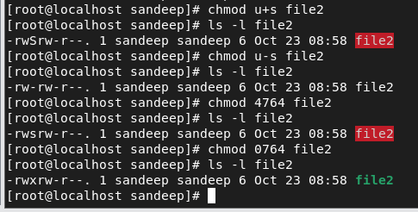

1. Become root user and create a shared full permission dir
   1. Become user sharedfolder and create files and dirs.

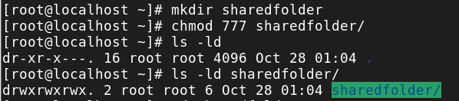

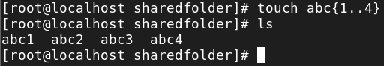

* 1. Login as another user and delete the files created by sharedfolder

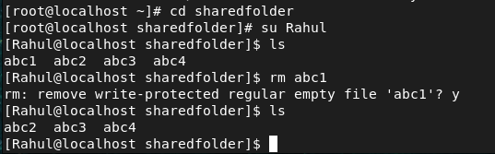

* 1. Now set sticky bit to the shared dir (chmod +t dirname) / chmod 1777 dirname)

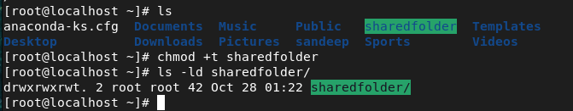

* 1. Again, as Rahul create dirs and files inside shared folder

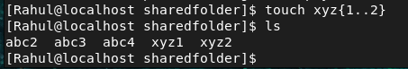

* 1. Login as another user and delete the files created by Rahul

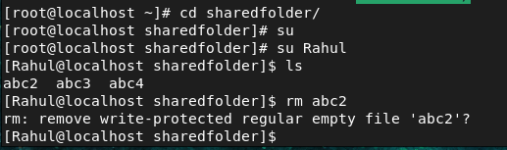

* 1. Observe the changes.

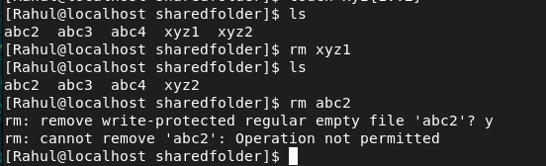

1